
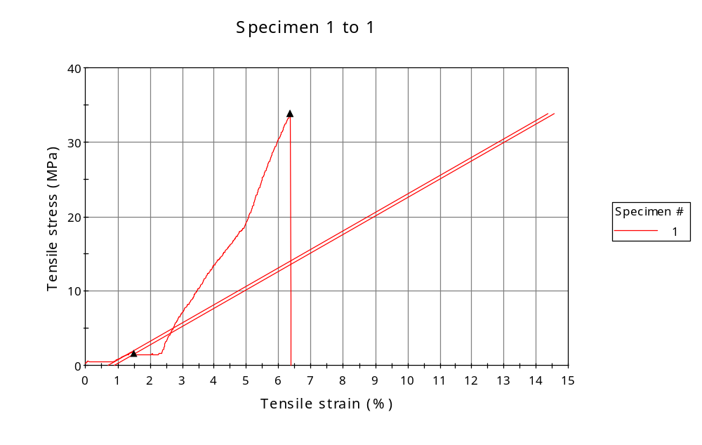
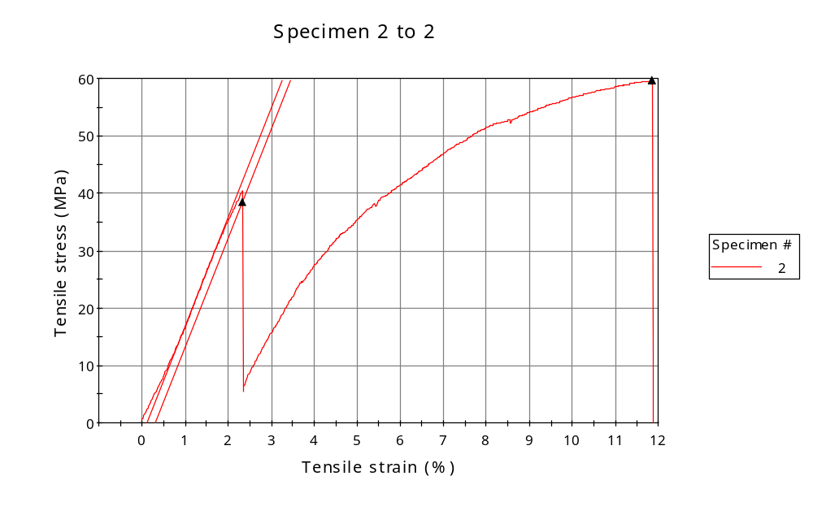
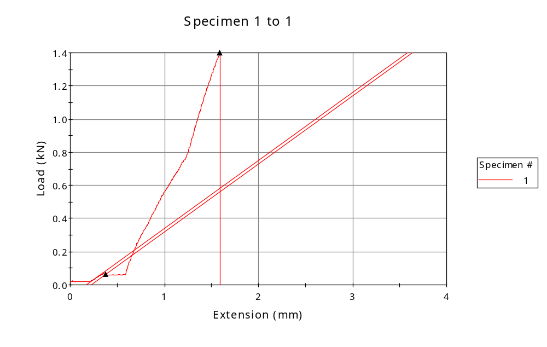
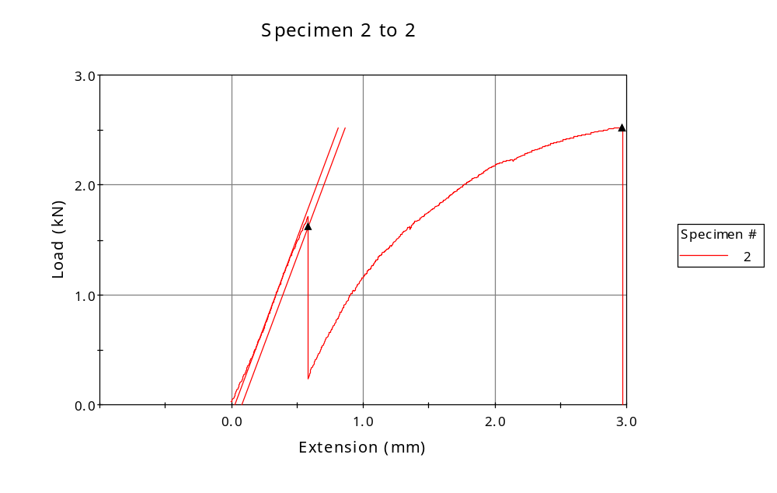

 | CP ID | Length  (mm) | Width  (mm) | Thickness  (mm) | Modulus (Automatic Young's)  (MPa)
1 | CP-01 | 25.00 | 6.00 | 6.90 | 247
2 | CP-02 | 25.00 | 5.80 | 7.30 | 1898
Maximum |  | 25.00 | 6.00 | 7.30 | 1898
Minimum |  | 25.00 | 5.80 | 6.90 | 247

 | Load at Fy ( 0.2 %) - LE  (kN) | Tensao em Fy ( 0.2 %) - LE  (MPa) | Deformacao em Fy ( 0.2 %) - LE  (%) | Forca Max  (kN) | Tensao na Forca Max - LR  (MPa)
1 | 0.065 | 2 | 1.512 | 1.398 | 34
2 | 1.625 | 38 | 2.334 | 2.524 | 60
Maximum | 1.625 | 38 | 2.334 | 2.524 | 60
Minimum | 0.065 | 2 | 1.512 | 1.398 | 34

 | Deformacao na Forca Max - LR  (%) | Forca na Forca na Quebra - LQ  (kN) | Deformacao na Forca na Quebra - LQ  (%) | Final length  (mm) | Final width  (mm)
1 | 6.360 | 1.398 | 6.360 | 119.00 | 7.00
2 | 11.866 | 2.524 | 11.866 | 119.00 | 8.00
Maximum | 11.866 | 2.524 | 11.866 | 119.00 | 8.00
Minimum | 6.360 | 1.398 | 6.360 | 119.00 | 7.00

 | Alongamento
1 | 3.76
2 | 3.76
Maximum | 3.76
Minimum | 3.76

